ANALYSIS OF INTERFERENCE BETWEEN LTE SYSTEM AND TETRA SYSTEM IN THE 800MHZ BAND

Fadhilah Natasha, Uke Kurniawan Usman2, Rizky Satria3
Telecommunication Engineering Teknik, Faculty of Electro Engineeting, Telkom University
fadhilahnatasha05@gmail.com, ukeusman@telkomuniversity.ac.id, satria.riz2007@gmail.com

Abstract
Wireless communication is used in many sectors to support the need of communication, the example of wireless communication is applied in mission critical network. Wireless communication system that used in mission critical are Terrestrial Trunked Radio (TETRA) and Long Term Evolution (LTE). TETRA systems supports voice services while LTE supports voice and data services. Co-exsitence between LTE and TETRA in same frequency band is one of the optimilazition quality for mission critical network. For this final project analyses interference in co-exsitence between LTE and TETRA in frequency band 800 MHz. There are four scenarios using extended-hata model propagation in urban area. There are several parameters that reviewed, desired Received Signal Strength (dRSS), interfering Received Signal Strength (iRSS), Carrier to Interference ratio (C/I) and probability of interference. In all scenarios occur Co-Channel Interference (CCI) between LTE and TETRA in frequency band 800 MHz so the performance not optimal. . The performance increased when add guard band variation. The variation that applied are 0,5 MHz, 0,75 MHz, 1 MHz. Based on the result of the simulation that have been done, proposed the used of guard band variation for elevate the performance.

Keywords: C/I, Interference, LTE, mission critical, probability of interference, TETRA.

1. Introduction
Nowadays application and choice of suitable wireless communication that can support optimization to elevate the quality that user need because of every time there is increasing in traffic but also frequency allocation is limited. Wireless communication offers many variant of technology for some sectors, one of the example is services for mission critical network.
One of the technology that used in mission critical communication is Teresstrial Trunked Radio (TETRA). TETRA has primacy that usual techonology don’t have. TETRA designed to offer wide coverage and high rate availbality network that can operate pretty well in disaster area. [1]. Along with the primacy TETRA also has lack and that is low data rate and smaller capacity if compare with usual cellular network. The lack that TETRA has make operator in mission network do coexesistence between TETRA with one of cellular technology, Long Term Evolution (LTE). LTE is a broadband technology . LTE network offer better quality if compare with previous generation of cellular technology.
Coexistence two different technology with same operate frequency could occur interference. In this research LTE and TETRA operate in 800 MHz band. LTE used 814-849 for uplink and 859-894 for downlink and TETRA used 806-824 MHz for uplink and 851-869 for downlink. The probability of interference that standardized by ETSI is 10%.

2 Basic Theory
2.1 Basic Theory of Interference
Coexsistence more thans one base station in same coverage could occur intereference between transmitter and receiver. In general interference divided into two category co-channel interference dan adjacent channel interference [3].
Co-channel interference is interference signal have same carrier frequency with information signal or interference signal entering receiver get close with the center of bandwidth so the filter could not muffle [3]. In other word co-channel interference is an interference between cell that use same channel or same frequency.
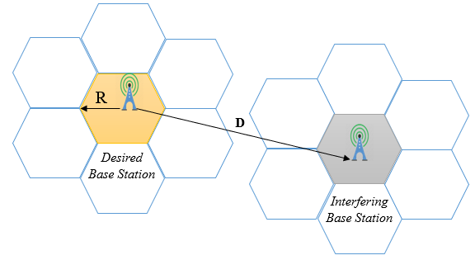
Picture 1 Co-channel Interference[4].
Interference that produce by assigned frequency with original signal defined as Adjacent Channel Intereference ( ACI) [5]. In other word ACI is an interference of assigned channel.
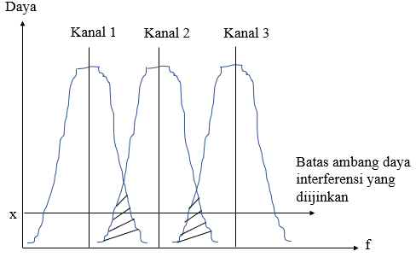
Picture 2 Adjacent Channel Interference [4].
2.2 Parameter yang digunakan
Parameters that being used in analysis of interference between LTE and TETRA are desired Received Signal Strength (dRSS), interfering Received Signal Strength (iRSS), and Probability of interference/Carrier to Interference (C/I).

dRSS is strength of victim wanted signal, a calculation of link budget between Victim Link Receiver (VLR) and Victim Link Transmitter (VLT) [6].
$dRSS= PowerTx+Gain Tx+Gain Rx-Pathloss$ (1)
$$where:$$
dRSS$= desired Received Signal Sterngth [$dBm]
$Power = transmit power from transmitter$[dBm]
$GainTx = total gain of transmitter$ [dBi]
$GainRx = total gain of transmitter$ [dBi]
Pathloss $= loss of link budget$[dB]

iRSS is calculation that consider as a link budget between VLR and Interfering Link Transmitter (ILT) [6].

$iRSS = PowerTx+Gain Tx+Gain Rx-Pathloss$ (2)
dimana
iRSS$= interfering Received Signal Sterngth [$dBm]
$Power = transmit powerfrom transmitter$[dBm]
$GainTx = total gain from transmitter$ [dBi]
$GainRx= total gain of transmitter$ [dBi]
Pathloss $= loss of link budget$ [dB]

Carrier to Interference (C/I) is measure that used to rate between signal quality and interference stated with C/I (dB). C/I should higher than C/I minimum that standardized by standardization [4].
- Perancangan Simulasi Sistem
3.1 Scenario design for Simulation on SEAMCAT
Each simulation on software SEAMCAT iterated with 21.000 samples. There are four scenarios simulated with each scenario with four schemes, co-channel (no guard band) and with guard band addition (0,5 MHz, 0,75 MHz, and 1 MHz). There are one interfereing link and one victim link in each scenario . In Interfering link there are Interfering Link Transmitter (ILT) and Interfering Link Receiver (ILR). In Victim Link there are Victim Link Transmitter (VLT) and Victim Link Receiver (VLR). Every scenarios produce dRSS, iRSS, C/I and probability of interference.

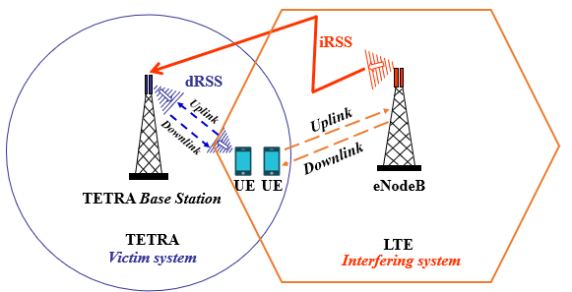
Picture 3 Scenario simulation on SEAMCAT

- Scenario 1 (Downlink LTE vs Downlink TETRA)
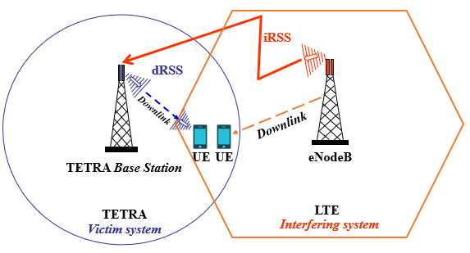
Picture 4 Scenario 1.
- Scenario 2 (uplink LTE vs Downlink TETRA)
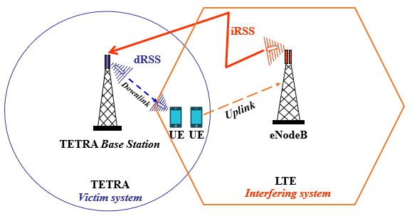
Picture 5 Scenario 2.

- Scenario 3 (Downlink LTE vs Uplink TETRA)
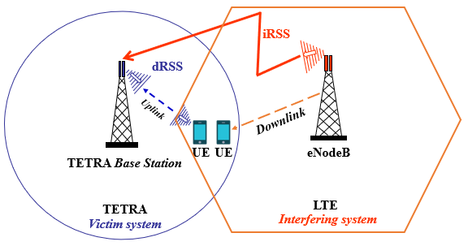
Picture 6 Scenario 3.
- Scenario 4 (Uplink LTE vs Uplink TETRA)
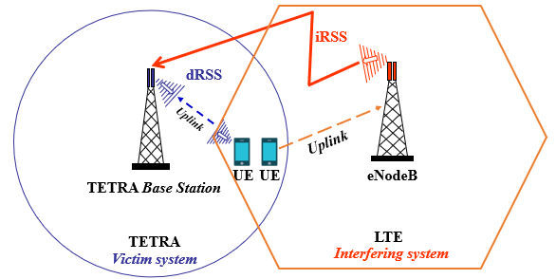
Picture 7 Scenario 4.

3.2 Flow Chart

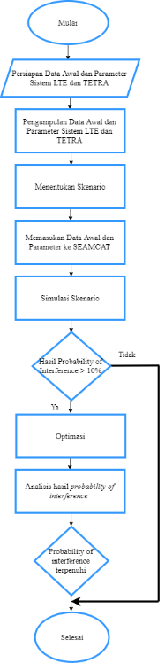
Gambar 8 flow chart of analysis of interference between LTE and TETRA.
4. Simulation and Analysis

4.1 Analysis of Scenario 1
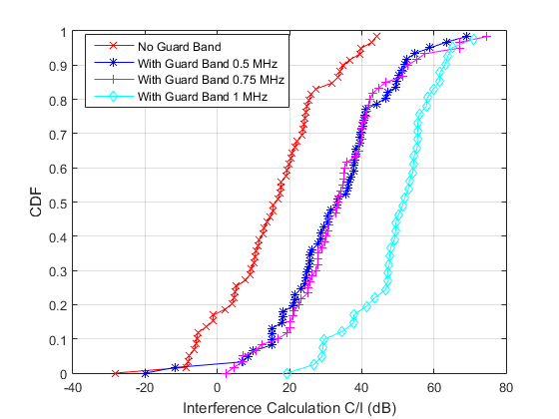
Gambar 9 Interference Calculation C/I Scenario 1.

Scenario |  | Mean of dRSS | Mean of iRSS | Mean of C/I | Probabilty of Interference | Fullfil ETSI Standard
Dowmlink LTE vs Downlink TETRA | Co-channel  (no guard band) | -89,39 dBm | -117,12 dBm | 26,81 dB | 35% | No
 | Guard Band 0,5 MHz | -89,19 dBm | -149,49 dBm | 64,71 dB | 1% | Yes
 | Guard Band 0,75 MHz | -89,16 dBm | -153,33 dBm | 66,33 dB | 0% | Yes
 | Guard Band  1 MHz | -89,99 dBm | -152,32 dBm | 71,52 dB | 0% | Yes

4.2 Analaysis of Scenario 2
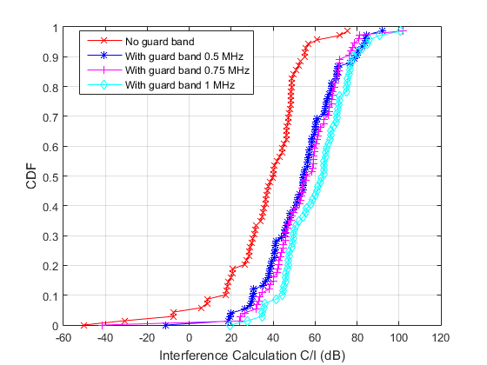
Picture 10 Interference Calculation C/I Skenario 2.
Scenario |  | Mean of dRSS | Mean  of  iRSS | Mean of  C/I | Probabilty of Interference | Fullfil ETSI standard
Uplink LTE vs Downlink TETRA | Co-channel (no guard band) | -96,94 dBm | -127,93 dBm | 35,47 dB | 16% | No
 | Guard Band 0,5 MHz | -95,16 dBm | -145,38 dBm | 53,05 dB | 2 % | Yes
 | Guard Band 0,75 MHz | -96,19 dBm | -146,36 dBm | 54,4 dB | 1 % | Yes
 | Guard Band  1 MHz | -97,27 dBm | -152,8 dBm | 60,53 dB | 0 % | Yes

4.3 Analysis of Scenario 3
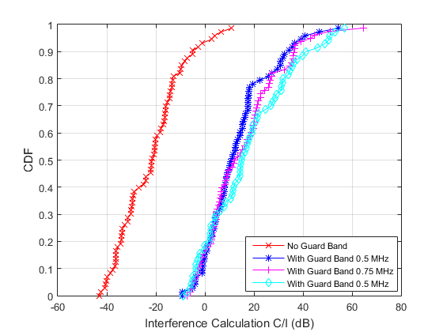
Picture 11 Interference Calculation C/I Scenario 3.

Scenario |  | Mean of dRSS | Mean of iRSS | Mean of C/I | Probabilty of Interference | Fullfil ETSI standard
Downlink LTE vs Uplink TETRA | Co-channel (no guard band) | -95,98 dBm | -70,03 dBm | -22,24  dB | 100% | No
 | Guard Band 0,5 MHz | -96,47 dBm | -105,67 dBm | 13,02 dB | 78 % | No
 | Guard Band 0,75 MHz | -94,82 dBm | -105,35 dBm | 14,84 dB | 61 % | No
 | Guard Band  1 MHz | -96,79 dBm | -108,64 dBm | 16,92 dB | 60 % | No

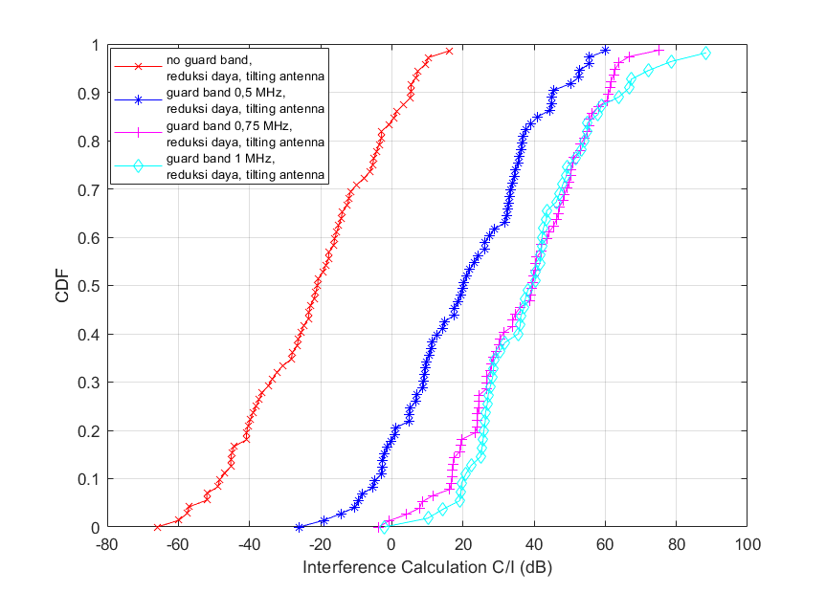
Picture 12 Interference Calculation scenario 3 after optimazition.
Scenario |  | Mean of dRSS | Mean of iRSS | Mean of C/I | Probabilty of Interference | Fullfil ETSI standard
Downlink LTE vs Uplink TETRA | Co-channel  (no guard band), Power reduction BS TETRA, and tilting antenna. | -103,65 dBm | -121,91 dBm | 26.54 dB | 80% | No
 | Guard Band 0,5 MHz, Power reduction BS TETRA, and tilting antenna. | -115,21 dBm | -74,31 dBm | 38.47 dB | 47% | No
 | Guard Band 0,75 MHz, Power reduction BS TETRA, and tilting antenna. | -99,07 dBm | -133,23 dBm | 42.99 dB | 12% | Yes
 | Guard Band  1 MHz, Power reduction BS TETRA, and tilting antenna. | -93,15 dBm | -153,05 dBm | 47.84 dB | 5% | Yes

4.4 Analysis of Scenario 4
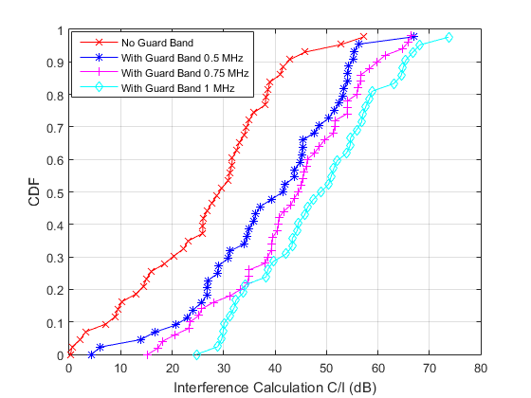
Picture 13 Interference Calculation scenario C/I Scenario 4.

Scenario |  | Mean of dRSS | Mean of iRSS | Mean of C/I | Probabilty of Interference | Fullfil ETSI standard
Uplink LTE vs Uplink TETRA | Co-channel  (no guard band) | -103,65 dBm | -121,91 dBm | 26.54 dB | 31% | No
 | Guard Band 0,5 MHz | -104,63 dBm | -134,80 dBm | 38.47 dB | 11% | No
 | Guard Band 0,75 MHz | -102,98 dBm | -136,81 dBm | 42.99 dB | 6% | Yes
 | Guard Band  1 MHz | -104,09 dBm | -140,60 dBm | 47.84 dB | 0% | Yes

Scenario |  | Probabilty of Interference (%) | Category
Scenario 1  Downlink LTE vs Downlink TETRA | Co-channel (no guard band) | 35% | Co-channel interference
 | Guard Band 0,5 MHz | 1% | Interference minimum
 | Guard Band 0,75 MHz | 0% | Interference minimum
 | Guard Band 1 MHz | 0% | Interference minimum
Skenario 2  Uplink LTE vs Downlink TETRA | Co-channel (no guard band) | 16% | Co-channel interference
 | Guard Band 0,5 MHz | 2 % | Interference minimum
 | Guard Band 0,75 MHz | 1 % | Interferensi minimum
 | Guard Band 1 MHz | 0 % | Interferensi minimum
Scenario 3  Downlink LTE vs Uplink TETRA | Co-channel (no guard band) | 100% | Co-channel interference
 | Guard Band 0,5 MHz | 78 % | Adjacent channel interference
 | Guard Band 0,75 MHz | 61% | Adjacent channel interference
 | Guard Band 1 MHz | 60% | Adjacent channel interference
Scenario 3  Optimization  Downlink LTE vs Uplink TETRA | Co-channel (no guard band) Power reduction BS TETRA, and tilting antenna | 80% | Co-channel interference
 | Guard Band 0,5 MHz, Power reduction BS TETRA, and tilting antenna | 47% | Adjacent channel interference
 | Guard Band 0,75 MHz, Power reduction BS TETRA, and tilting antenna | 12% | Adjacent channel interference
 | Guard Band 1 MHz, Power reduction BS TETRA, and tilting antenna | 5% | Interference minimum
Scenario 4  Uplink LTE vs Uplink TETRA | Co-channel (no guard band) | 16% | Co-channel interference
 | Guard Band 0,5 MHz | 2% | Interference minimum
 | Guard Band 0,75 MHz | 1% | Interference minimum
 | Guard Band 1 MHz | 0% | Interference minimum

- Conclusion

- Based on the results of simulation there are three categories. Co-Channel Interference (CCI), Adjacent Channel Interference (ACI) and Interference minimum.
- CCI occur if the probability of interference value is above 10%, and when LTE and TETRA operate in the same frequency (800 MHz).
- ACI occur if the the probability of interference is above 10 % after added guard band.
- Interference minimum occur if probability of interference is below 10%.
- Based on final result of simulation that have been analysed, suggested to use minimum guard band 1 MHz for scenario 1,2,3,and 4 to avoid degradation performance between LTE and TETRA that caused by interference. And for optimization for scenario 3 suggested to do power reduction of TETRA base satation and tilting antenna eNodeB and TETRA base station.

References:
[1] | W. H. Y. Commercial, N. Are, and N. O. T. Enough, “Mission Critical Communications Designed To a Tougher Standard,” pp. 1–6, 2012.
[2] | TCC, “Tetra and lte working together,” no. 4155039, 2014.
[3] | A. Oudah, T. A. B. D. Rahman, and N. Seman, “Coexistence and sharing studies of collocated and non- collocated fourth generation networks in the 2.6 GHZband,” J. Theor. Appl. Inf. Technol., vol. 43, no. 1, pp. 112–118, 2012.
[4] | Commtech Indonesia, “SEAMCAT Training-Setyono.” COMMTECH INDONESIA.
[5] | T. I. B. M. Sesia Stefania, LTE The UMTS Long Term Evolution. 2011.
[6] | European Conference of Postal and Telecommunications Administrations (CEPT), “Seamcat,” Spectr. Eng. Adv. Monte Carlo Anal. Tool, vol. ECC REPORT, no. April, 2016.

